The final piece of The Sieve is the sieve function which constructs a network of filters to sieve out the primes.
At any one time there is an existing network of filters removing multiples of prime numbers found so far. For example, after processing 13, the next number to look at will be 15 and the network of filters will look like:
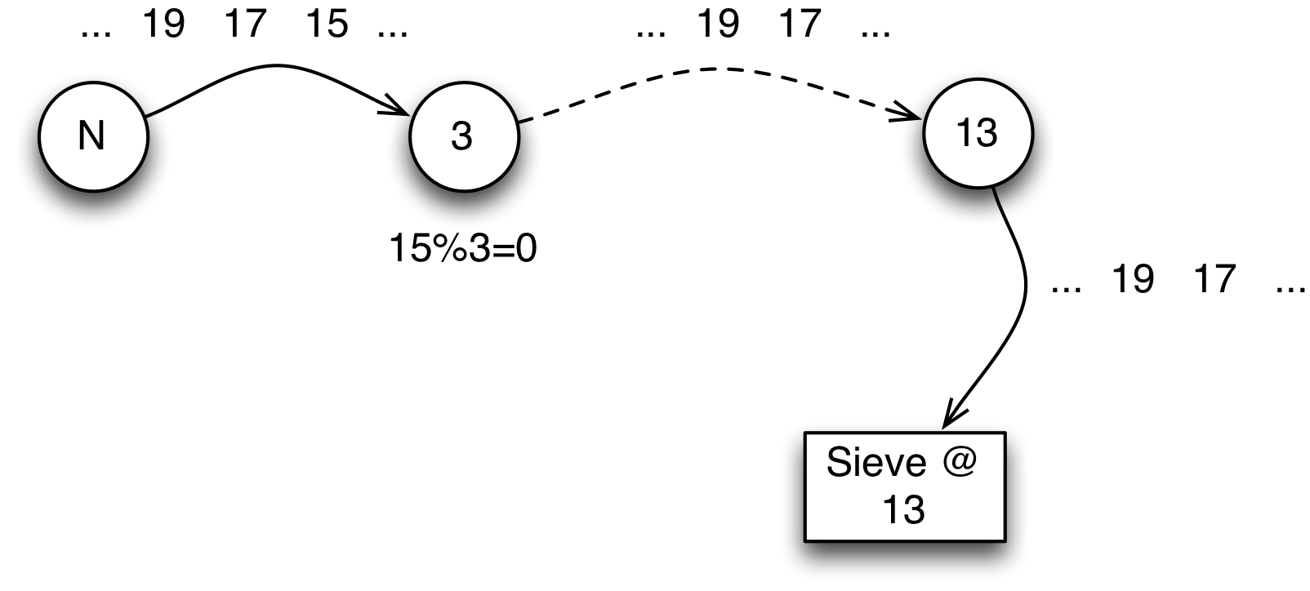
The Sieve of Eratosthenes at 13
The 3 filter removes 15 because 15 is a multiple of 3. However, the following number — 17 — survives all the filters and the sieve responds by spinning off a new filter for 17 at the end of the chain:
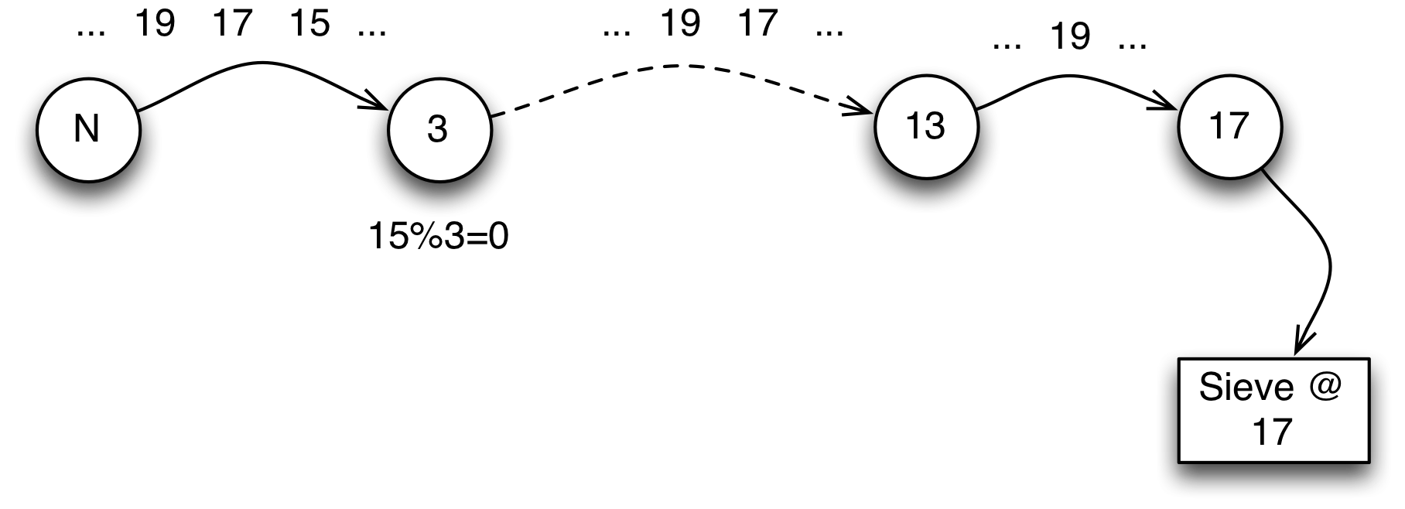
The Sieve of Eratosthenes at 17
I.e., The Sieve also receives input from a source, but its response is to spin off a new filter. We can program this using the sieve function:
fun sieve0(inChannel) is valof{
def nxPrime is valof (wait for recvRv(inChannel))
valis sieve0(filter(nxPrime,inChannel))
}
The crux of the sieve function is that the same channel that it is listening to for the next prime number is then passed to the newly created filter task and the result of that filter will be the input for the next cycle of the sieve.
This variant of The Sieve does not report the primes it finds; in fact, it will not terminate until the stack overflows. A more appropriate variant will find a list of primes up until some number. We first of all engineer another task that listens to a channel for a sequence of terms and collects the result into a list:
fun collectTerms(ch,Count) is background task{
var data := list of []
for cx in range(0,Count,1) do {
def nxt is valof ( wait for recvRv(ch) )
data := list of [data..,nxt]
}
valis data
}
Given this function, we augment our sieve with the additional channel for sending the results to:
sieve(inChannel,results) => valof{
nxPrime = valof (wait for recvRv(inChannel))
perform wait for sendRv(results,nxPrime)
valis sieve(filter(nxPrime,inChannel),results)
}
The complete system can be put together into a primes function that uses multiple tasks to sieve for primes:
primes(Max) => let{
resltCh = channel().
{ ignore background task { valis sieve(naturals, resltCh)}}
} in valof collectTerms(resltCh,Max)

